**IT204F Project Report**

**Group Members:**

**Mohamed Ameer Ashraf Ali (220906Q)**

**Wu Zhe Ming (220885D)**

**Lim Kai Yi (220840Y)**

**Jackie Soon (221139Y)**

**Introduction:**

In today’s fast-paced and ever-evolving society, technology has advanced rapidly over recent years. Many industries are transitioning to the digital world. One of the industries is the entertainment industry. Entertainment used to be via physical performances like a circus or opera. Now with newer technology, the majority of entertainment now is through digital platforms like Youtube and Facebook. In the children’s entertainment industry, most parents are not always able to give their children their time and need to distract them with something entertaining while they are preoccupied with their own things and work. Hence, we made a platform that contains various entertaining and educational games fit for the children's entertainment industry for those aged between 6 and 12 years old.

**Industry Needs:**

1. **Entertainment**

The 1st industry’s need is to entertain young children while their parents are busy. This is because parents do not always have the luxury of attending to their kids at all times, whether this is at home, or outside. They need some time away from their kids to take care of their own affairs and hence need a way to entertain and distract their kids while doing so. Hence, we can create entertaining games that pique the children’s interests. The children will be preoccupied with these games while their parents are busy, which is a win-win situation. Children from 6 to 8 years old generally should not have screen time of more than 1 hour a day while children from 9 to 12 years old should have no longer than 2 hours a day.

1. **Education**

The 2nd industry’s need is the ability to educate children through entertainment. Be it either in games, shows, or documentaries. Education for kids at a young age is important as research has shown that children's brains are more open to learning new skills like reading, writing and playing a physical instrument. Hence, when children start to learn earlier at a young age, they are able to perceive and understand better while at the same time developing their brains. Furthermore, children at a very young age to have emotions has always been something a parent would want children to have. Having the entertainment to educate children on emotions is a better way for children to understand emotions better. However, it is not always good to educate children's emotions through entertainment. It would be best if the parents are there to educate their child physically.

1. **Convenience**

The 3rd industry's need is to improve the convenience of toys. Physical toys require ample space to play and store after use. Not every household has the space to support a wide variety of toys. Cleaning up and packing up toys is also time-consuming. This is why toys need to be digitalised onto electronic devices to make them more convenient for children and parents to use.

1. **Demand**

The fourth industry’s need is to supply the demand for educational online games that are convenient and cheap. Parents nowadays are looking for things that are cheap and convenient due to the increased cost of living and it being easier to manage. Since most parents possess electronic devices the game would be very convenient for them at the same time since the games are free, It can be afforded by all. At the same time, parents tend to look for electronic games for their kids as it is very convenient and they already possess the devices needed to play those games which we are trying to accommodate.

**How The Application Helps The Industry:**

Empathy For User

This application empathises with working parents that do not have time to educate and entertain their children by having games in place to facilitate their child's learning. Our application has a variety of games like Math Quizzes, English Quizzes, and Strategic Games as well as an emotions display function. Having these games in place helps their child to learn the same things in alternative to their parents that do not have time to cater for them.

Adds Value To Business

This application adds value to the business as it fulfils the business needs of this industry of education, entertainment, convenience and demand. Since this application has education and entertainment games, it fulfils the need of educating children on basic thinking skills and fulfils the need for entertainment with fun and engaging games. Having this application digitalised also makes it convenient as all users need to do is download and open the app on their mobile devices or tablets. There is no need to pack up after playing. This digital innovation sparks interest in the entertainment industry and helps increase the demand for this application and as a whole, the entertainment industry for children.

Feasibility

This application is feasible as it can be easily created with basic software like scratch. Our application consists of simple games such as simple mathematics and English quizzes, simple collect and avoids games and a space defender game and so on. All these games are simple, easy and uncomplicated to play and understand. This allows the children to play the game without supervision from their guardian thus making it feasible for children to play.

Realistic

This application is realistic as it is easily implementable. Generally, all children or parents have a smartphone these days, allowing our application to be easily distributed to their devices since it is software. It is easy to use and set up on any mobile device. This allows parents to give their children the entertainment they need while they are busy with something else, no matter what time it is or where they are.

Practical Workflow

Once the application platform that contains the game is made, more games can be added in future. The current 5 games, 3 of which are educational and 2 of which are entertainment, already fulfil the business needs and digital innovation that this industry requires. As more games are added on, it helps expand the application and the demand for it.

**Application Solution:**

The application is a platform that contains various entertaining and educational games fit for the children's entertainment industry. This also solves the problem of many children having busy parents. By having this application, children would keep themselves entertained and educate themselves through the games in our application.

**Educational Games**

**Maths Quizzes Game [Ameer]**

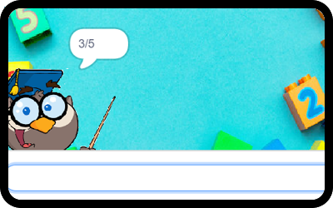

10 Questions for each difficulty.

* Easy (Addition + Subtraction)  
   11+17 = 38/26/28/24 → Choose the correct answer (+ - Basic Operations)
* Medium(Multiplication)  
   2x2= 4/8/12/16 (Choose correct answer) (x / Basic Operations)
* Hard (Division)  
   1.1+2.7 = 3.9/3.8/3.1/10.1 (Choose correct answer) (Decimal Basic Operations)

**English Quizzes (ABC, simple words) [Kai Yi]**

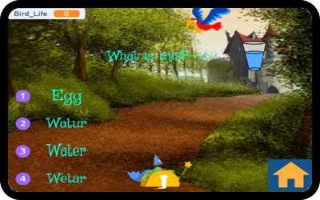

* 8 questions that test various grammar, tenses, vocabulary and spelling.
* The screen would show a sentence and the player would have to select if the sentence is grammatically correct or not.
* An example is spelling. A picture of an apple will be shown with the question asking “What is this?” Four options will be shown with different spelling of “Apple” with one of the words spelled correctly.
* The game would end once all question are shown

**Emotions (Happy, Sad, Excited, Angry) [Zhe Ming]**

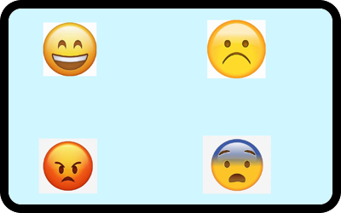

* A game where it teaches children about emotions.
* Icons on the screen depict different emotions like Angry, Sad, Excited, Happy.
* When clicking on the angry face icon in the game, the sprite will change to the corresponding emoji name. Similarly for other emotion icons as well.

**Entertainment Games**

**Space Defender [Jackie]**

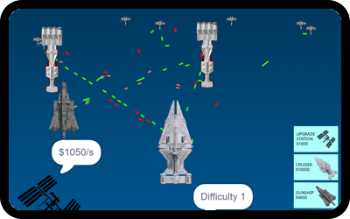

There are 5 levels and an endless mode.

For each level,

The goal of the game is to survive the attackers.

To win, players must all the attacking ships.  
Each level gets progressively harder.  
Each level will have attacking ships.

Players must use their money wisely on ships to defend Earth.

Players earn money by upgrading their space station and surviving.

For endless mode,

It is the same as the levels, but more attacking ships spawn as you survive for a longer period of time.  
The goal is to survive as long as possible.

**Spongebob Burger Collectors (Doge & Collect) [Zhe Ming]**

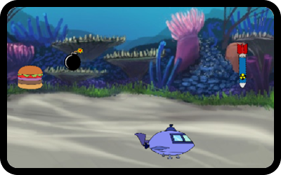

* The goal of the game is to collect a certain number of burgers and avoid bombs to win the game.
* Bombs and Burgers will be randomly dropped down from the top of the screen.
* Players must make use of the left arrow key and right arrow key to avoid the bombs and at the same time collect the fallen burgers.
* To get one score, players have to use the boat and collect a burger.
* One score will be deducted if the boat touches the bomb. The game ends when the number of scores reaches 20 or reaches 0.

**References:**

[Screen Time Recommendations by Age (allaboutvision.com)](https://www.allaboutvision.com/conditions/refractive-errors/screen-time-by-age/#:~:text=As%20a%20general%20rule%2C%20limit%20recreational%20screen%20time,the%20benefits%20of%20mixing%20in%20some%20educational%20content.)

[Toys R Us' last two stores in the U.S. are closed for good (cnbc.com)](https://www.cnbc.com/2021/01/29/toys-r-us-last-two-stores-in-the-us-are-reportedly-closed-for-good.html)